Application Name
Work Breakdown Structure

Project Planning and Management (Leader: Pasaoa)
- Task 1: Finalize roles and WBS
- Task 2:Set up GitHub repository
- Task 3:Create and monitor the project schedule
- Task 4:Final compilation and submission

User Interface/ User Experience Design (Designer: Penuliar)
- Task 1 Create the user flow diagram
- Task 2 Design the wireframes
- Task 3 Revise the designs based on team feedback
- Task 4 Provide final UI assets to the programmers

Application Development (Programmer: Nalos,)
- Task 1 Core features
  - Sub-task: Set up the project structure
  - Sub-task : Build the main feature (halimbawa, scheduling)
- Task 2 :Supporting features and UI integration
  - Sub-task: Apply the wireframe designs to the app
- Task 3 Integration of all features
  - Sub-task: Connect all the features together
- Task 4 Bug fixes

Quality Assurance and Testing (Tester: Garcia)
- Task 1: Create the test plan
- Task 2: Create the test case matrix
- Task 3: Testing and bug reports (GitHub Issues)
- Task 4: Retest the fixed bugs

Technical Documentation (Documenter: Pantaleon)
- Task 1: Write the SRS (system features and requirements)
- Task 2: Include the test plan in the new SRS
- Task 3: Final documentation
- Task 4: Review and proofread all documents

Application Name
Project Schedule

TASK | ASSIGNEE | START DATE | FINISH DATE | DURATION
Phase 1 : Planning and Design
Task 1 : Finalize roles and WBS; set up GitHub repository | Pasaoa | Oct. 12, 2026 | Oct. 13, 2026 | 1 day
Task 2 : User flow diagram | Penuliar | Oct. 12, 2026 | Oct. 13, 2026 | 1 day
Task 3 : Wireframes | Penuliar | Oct. 12, 2026 | Oct. 13, 2026 | 1 day
Phase 2 : : Test Planning and SRS
Task 1: test plan | Garcia | Oct. 12, 2026 | Oct. 13, 2026 | 1 day
Task 2: Test case matrix | Garcia | Oct. 12, 2026 | Oct. 13, 2026 | 1 day
Task 3 : SRS: system features and requirements | Pantaleon | Oct. 12, 2026 | Oct. 13, 2026 | 1 day
Task 4 : Include test plan in new SRS | Pantaleon, Garcia | Oct. 13, 2026 | Nov, 3 2026 | 20 days
Phase 3 : Application Development
Task 1 : Core features | Nalos | Oct. 14, 2026 | Oct. 24, 2026 | 10 days
`Task 2 : Supporting features and UI integration | Penuliar | Oct. 14, 2026 | Oct.28 , 2026 | 14 days
Task 3:Integration of all features | Nalos, Penuliar | Oct. 14, 2026 | TBL | TBL
Phase 4 : Testing and Finalization
Task 1 : Testing and bug reports (GitHub Issues) | Garcia | Oct. 14, 2026 | TBL | TBL
Task 2 : Bug fixes and final documentation | Nalos, Penuliar | Oct. 13, 2026 | TBL | TBL
Task 3 : Final compilation and submission | Pasaoa | Oct. 13, 2026 | TBL | TBL

EASECHEDULE
User Flow Diagram

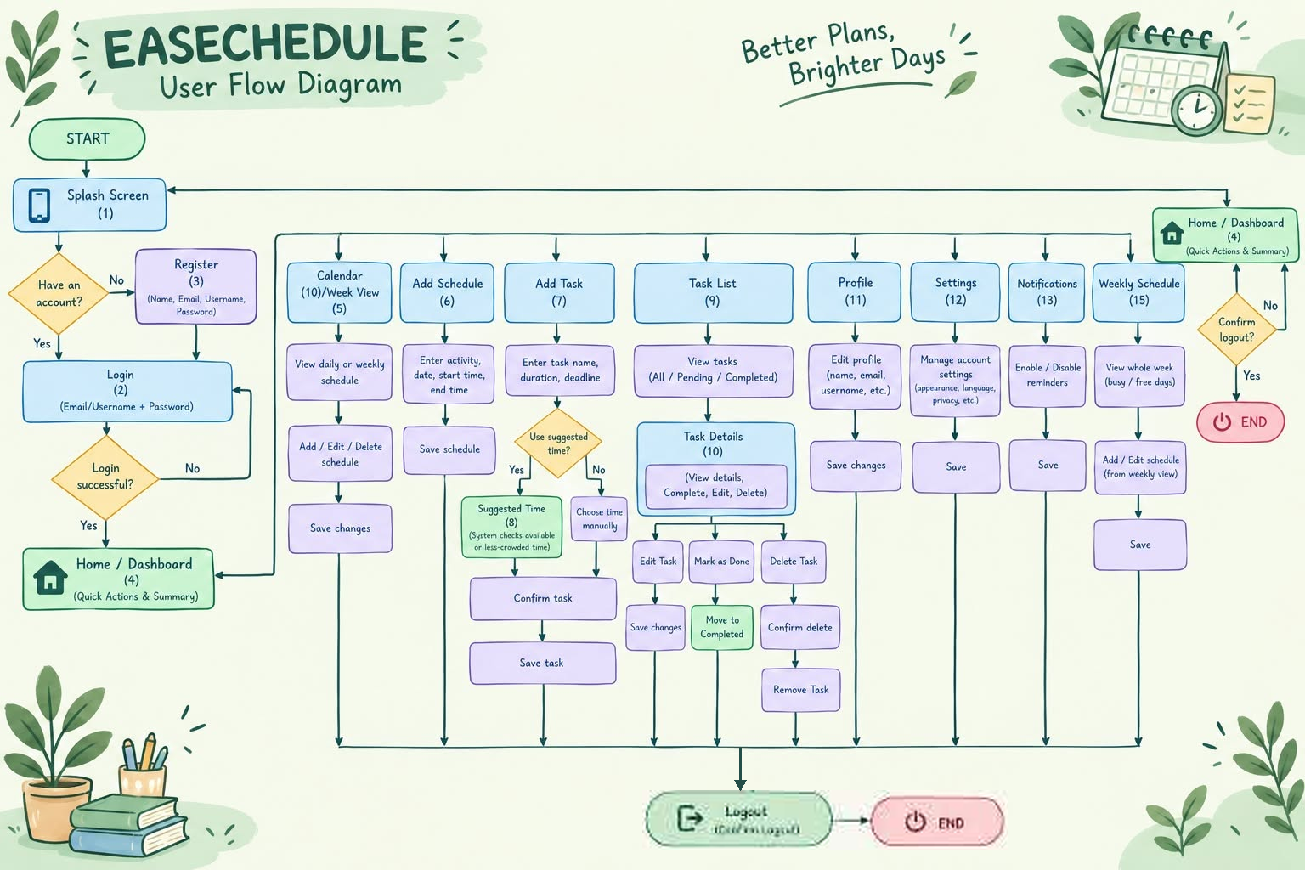

EASECHEDULE
Wireframe

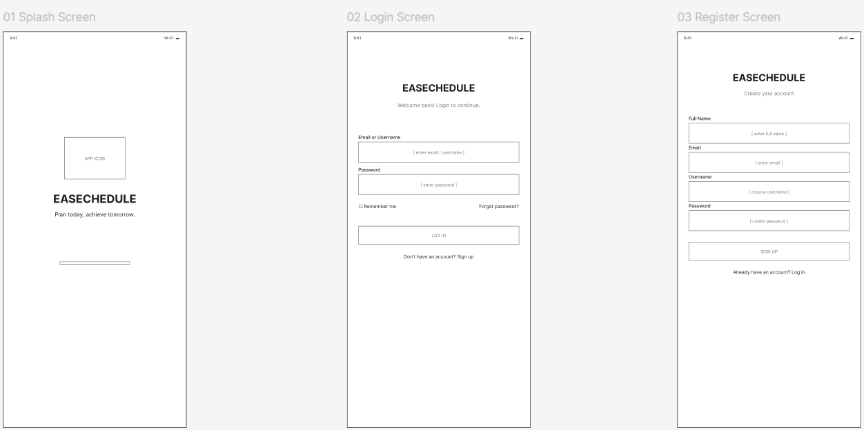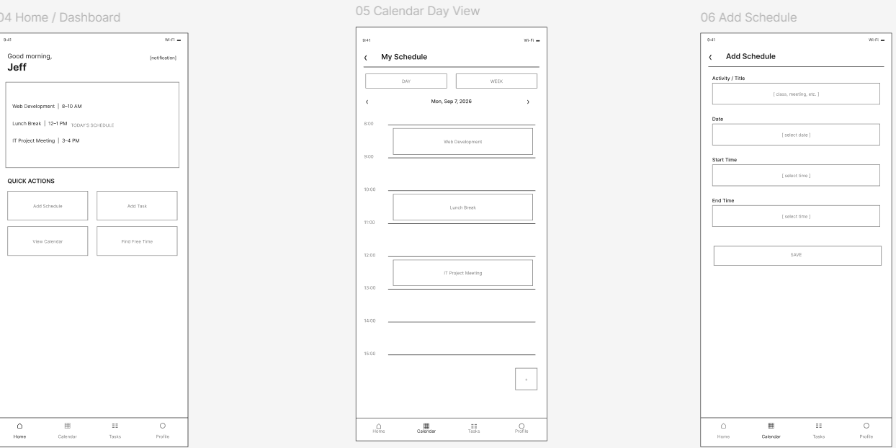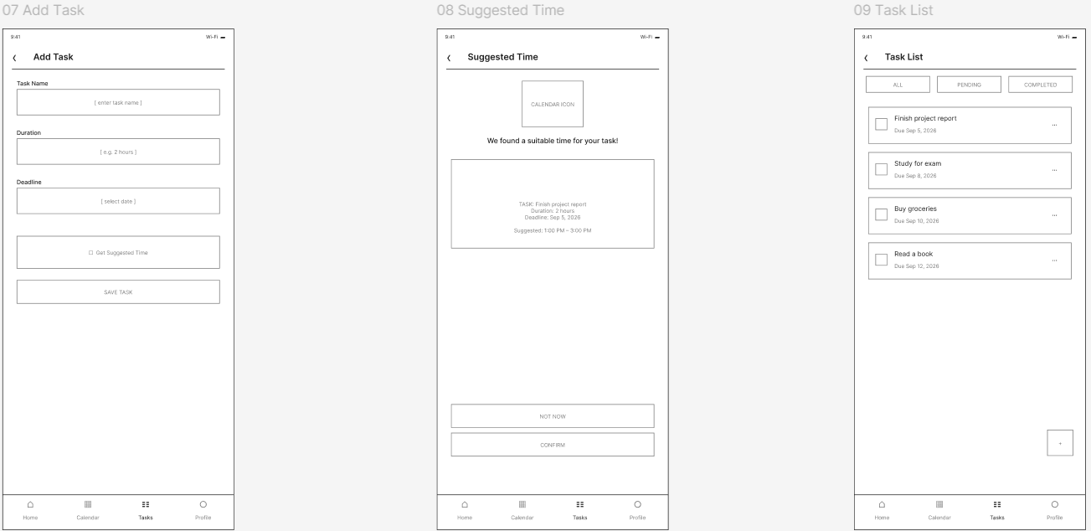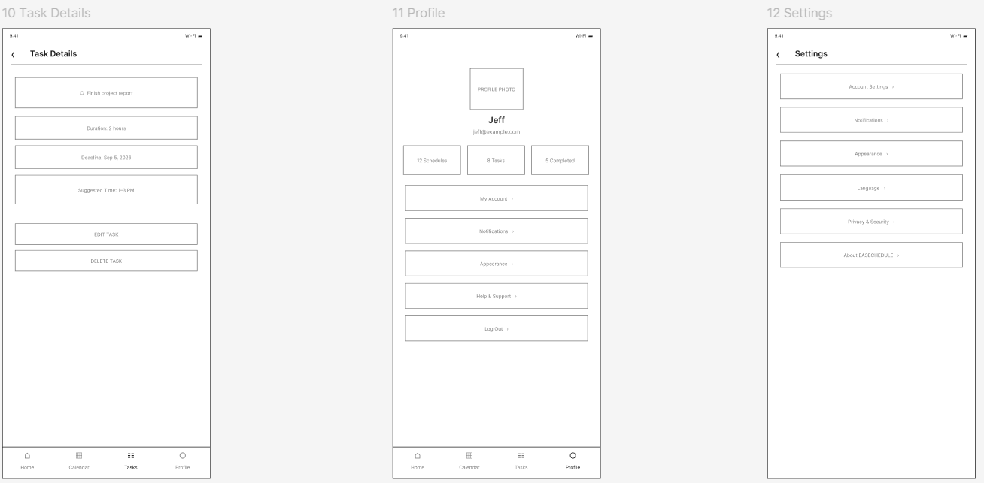
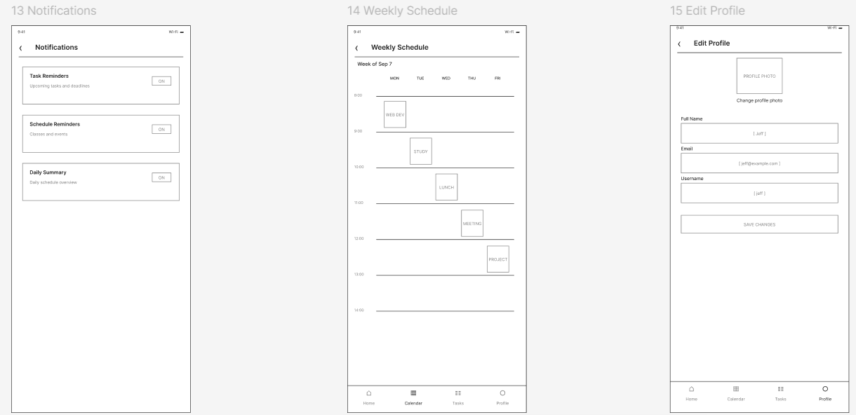

EASECHEDULE
Repository Setup

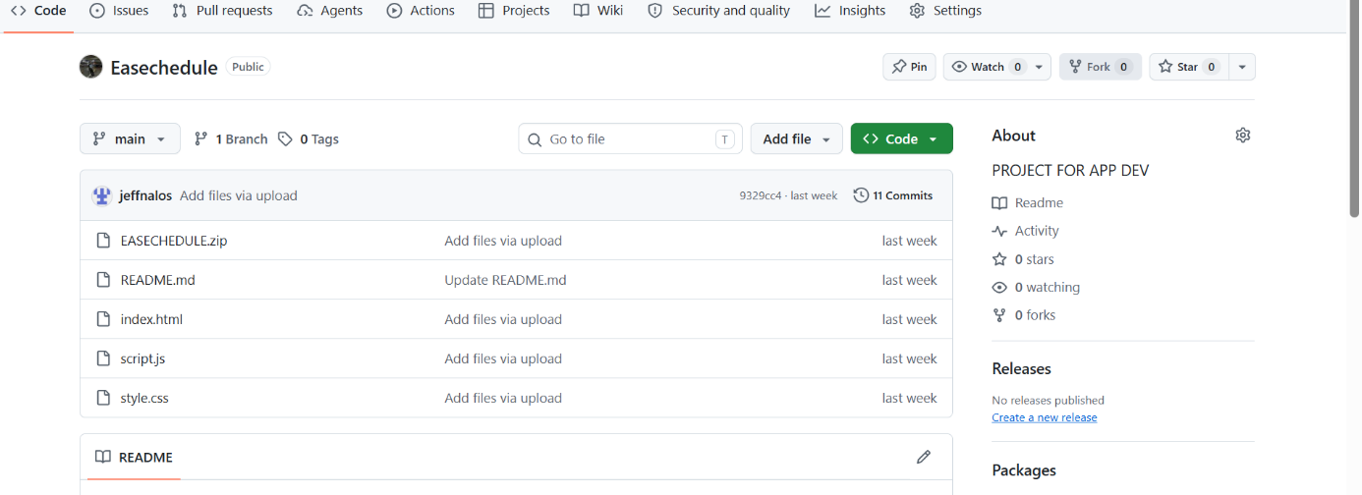

EASECHEDULE
Test Plan Strategy

Framework: Flutter QA Tester: Jeric Garcia
Target Platform: Android/iOS Timeline: Weeks 1–6

1. Objective & Scope
The objective of this test plan is to verify that the EaseChedule mobile application functions correctly, provides a user-friendly interface, and allows users to manage their schedules and tasks efficiently. Testing will compare the implemented application against the provided UI mockup in Figma and verify that its features work as expected on Android and/or iOS devices.
The testing process aims to identify defects, usability problems, navigation errors, and inconsistencies before the application is released.

In-Scope (What We Test):
The following features and components will be included in testing:
- Splash Screen — Verify that the application launches correctly and displays the EaseChedule logo and loading screen.
- Login and Sign-Up — Verify input validation, account creation, login, password handling, and navigation between authentication screens.
- Home Dashboard / Task List — Verify that the dashboard displays the user's schedule, task summary, and quick actions correctly.
- My Schedule / Weekly Schedule — Verify that scheduled events appear on the correct dates and times, that daily and weekly views work correctly, and that schedules can be edited and deleted.
- Add Schedule — Verify that users can enter an event title, select a date, set start and end times, and save a schedule.
- Add Task — Verify that users can enter a task name, set a deadline and duration, and save the task.
- Suggested Time — Verify that, when adding a schedule, the application displays an appropriate suggested time based on the user's existing schedule (available or less-crowded periods) and that the user can accept it or choose a time manually.
- Task Details — Verify that task information is displayed accurately and that editing, marking as done, and deleting tasks work correctly.
- Task List — Verify that tasks can be viewed and filtered by All, Pending, and Completed.
- Profile and Set Profile — Verify that users can view and update their profile information.
- Settings — Verify that settings options open correctly and that supported preferences can be changed.
- Notifications — Verify that task reminders and schedule reminders can be enabled or disabled and behave according to their configured settings.
- Logout — Verify that a confirmation prompt is displayed and that the session ends only after the user confirms.
- Navigation and UI Consistency — Verify bottom navigation, buttons, icons, input fields, screen transitions, spacing, colors, typography, and touch targets against the Figma design.
- Data Handling — Verify that saved tasks, schedules, and profile changes persist correctly when the application is reopened, where persistence is supported.
- Basic Performance and Compatibility — Verify that screens load properly, common actions respond without excessive delay, and the application works on the required test devices.

Out-of-Scope (What We Do NOT Test):
The following items will not be covered in the project requirements:
- Third-party services and external systems that are outside the application's control.
- Large-scale load testing involving thousands of concurrent users.
- Unsupported devices, operating systems, and screen sizes outside the agreed testing environment.
- Features not shown in the approved mockup or specified in the project's requirements.
- App store publishing, marketing, and post-release maintenance.

2. Testing Approach
- UI/UX Testing: Ensure the application's appearance, layout, and interactions are consistent with the approved Figma design and easy to use.
- Functional Testing: Verify that each feature performs its intended function and handles invalid inputs appropriately.
- Integration Testing: Verify that related features work together and that data is transferred correctly between screens and application services.
- Regression Testing: Ensure that previously working features continue to work after bug fixes, code changes, or new features are introduced.

3. Testing Environment & Tools
- Devices:
  - Android Emulator
  - Physical Devices: At least 1 Physical Android Device & 1 Physical iOS Device for touch target and performance sanity checks.
- Tools:
  - Visual Target: Figma
  - Defect Tracker: GitHub Issues

EASECHEDULE
Test Case Matrix

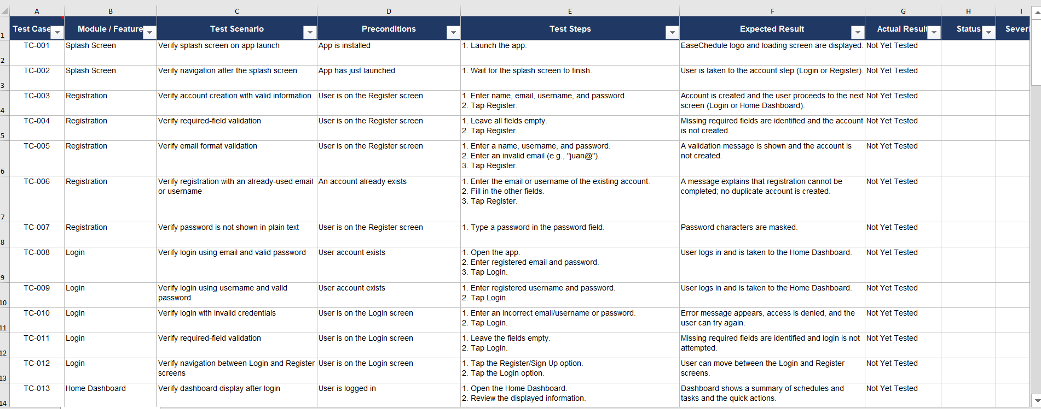

EASECHEDULE
Software Requirements Specifications

1. Introduction

Purpose
This Software Requirements Specification (SRS) document defines the functional and non-functional requirements of EASECHEDULE. It describes how the system allows users to organize schedules, manage tasks and deadlines, identify available time slots, receive suitable time suggestions, and manage account preferences.

Scope
EaseChedule is a scheduling and task-management application intended to help users organize activities, manage tasks, view schedules, and receive reminders. Users enter the application through a splash screen and can register or log in. After successful authentication, the user is directed to the Home/Dashboard, where the main scheduling, task, account, and settings features can be accessed.

In-Scope:
- Splash screen and account registration and login.
- Home/Dashboard with quick actions and a summary.
- Calendar with daily and weekly schedule views, including schedule creation, editing, and deletion.
- Add Schedule feature with activity, date, start time, and end time inputs.
- Suggested Time feature that checks available or less-crowded time periods, with an option to choose a time manually.
- Task creation with task name, duration, and deadline.
- Task List showing all, pending, and completed tasks.
- Task Details with options to edit, mark as done, and delete a task.
- Profile editing for name, email, username, and related profile information.
- Settings for appearance, language, privacy, and other account preferences.
- Notifications with the ability to enable or disable reminders.
- Weekly Schedule view and schedule editing from that view.
- Logout with a confirmation step.

Out-of-Scope:
- Social sharing, group scheduling, or collaborative task assignment.

Document References
- EaseChedule User Flow Diagram
- EaseChedule Test Plan and Test Case Matrix
- EaseChedule User Interface Wireframes
2. Overall Description

User Classes and Characteristics
- Registered User: A person who creates an account or logs in to create and manage personal schedules and tasks. The user can view the calendar, weekly schedule, task list, profile, settings, and reminders.
- Unregistered Visitor: A person who opens the application and can proceed to registration or choose the login path if an account already exists.
- System: The application logic that validates account inputs, stores user schedules and tasks, checks schedule availability for suggested times, and manages reminder preferences.

Operating Environment
- Client Platform: EaseChedule is a cross-platform mobile application developed using Flutter and targets Android and iOS devices.
- Hardware Specifications: A device capable of running the selected target platform and displaying the application interface.
- Network Requirements: A network connection may be required for account access and data synchronization if the final implementation uses an online backend.

Constraints
- The application must follow the screens, actions, and navigation paths represented in the approved EaseChedule user flow diagram.
- Registration and login must collect the fields shown in the user flow diagram: name, email, username, and password for registration; email/username and password for login.
- Suggested Time must be based on schedule availability or less-crowded time periods, as indicated in the user flow diagram.
- The application is developed using Flutter for Android and iOS. The data-storage method, security standard, and notification mechanism remain implementation decisions of the development team.

Assumptions and Dependencies
- Users provide valid account information when registering or logging in.
- The system has access to the user's saved schedules and tasks when generating a suggested time.
- Date and time values are entered or displayed using the device's supported date and time settings.
- Reminder delivery depends on the notification capabilities and permissions of the final target platform.
- The final application design will provide the screens and controls needed to carry out the actions shown in the user flow diagram.

3. System Features & Functional Requirements
Each requirement below is derived from the features and actions shown in the provided EaseChedule user flow diagram.

FR-01: Splash Screen and Navigation
- Description: The system shall display a splash screen when the application is launched and provide a route to the account access flow.
- Inputs: Application launch.
- Outputs: Splash screen and navigation to the account decision step.
- System Response:
- Display the EaseChedule splash screen.
- Provide the next step for users to indicate whether they already have an account.
- Direct users with an existing account to Login.
- Direct users without an account to Register.

FR-02: User Registration
- Description: The system shall allow a new user to create an account.
- Inputs: Name, email address, username, and password.
- Outputs: A newly created user account or a validation message.
- System Response:
- Display the registration form.
- Accept the user's name, email, username, and password.
- Validate required fields and the format of the supplied information.
- Create the account when the information is accepted.
- Display an appropriate message if registration cannot be completed.

FR-03: User Login and Authentication
- Description: The system shall allow an existing user to access the application using an email address or username and password.
- Inputs: Email address or username, and password.
- Outputs: Authenticated session and access to Home/Dashboard, or an error message.
- System Response:
- Display the login form.
- Validate that the required login fields are provided.
- Check the submitted credentials.
- If authentication succeeds, open Home/Dashboard.
- If authentication fails, display an error and allow the user to try again.

FR-04: Home/Dashboard
- Description: The system shall provide a central dashboard containing quick actions and a summary of the user's scheduling and task information.
- Inputs: Authenticated user session and saved schedule/task information.
- Outputs: Home/Dashboard with navigation to the main application features.
- System Response:
- Display the Home/Dashboard after successful login.
- Show a summary of relevant schedule and task information.
- Provide access to Calendar, Add Schedule, Add Task, Task List, Profile, Settings, Notifications, and Weekly Schedule.
- Allow the user to navigate to a selected feature.

FR-05: Calendar and Schedule Management
- Description: The system shall allow users to view schedules by day or week and add, edit, or delete schedule entries.
- Inputs: Selected calendar date or week; schedule details and requested action.
- Outputs: Updated daily or weekly calendar view and saved schedule entries.
- System Response:
- Display the calendar in daily or weekly view.
- Show schedule entries for the selected day or week.
- Allow the user to add a schedule entry.
- Allow the user to edit an existing schedule entry.
- Allow the user to delete a schedule entry.
- Save changes and refresh the displayed schedule.

FR-06: Add Schedule and Suggested Time
- Description: The system shall allow users to enter a schedule and optionally use a suggested time based on schedule availability.
- Inputs: Activity, date, start time, end time, and the user's choice to use a suggested time or choose a time manually.
- Outputs: A saved schedule with the selected date and time.
- System Response:
- Display fields for activity, date, start time, and end time.
- Offer the Suggested Time option.
- When requested, check the user's existing schedule for available or less-crowded time periods.
- Display a suggested time when one is available.
- Allow the user to accept the suggested time or choose a time manually.
- Allow the user to confirm and save the schedule.

FR-07: Task Creation
- Description: The system shall allow users to create a task with a task name, duration, and deadline.
- Inputs: Task name, duration, and deadline.
- Outputs: A newly saved task available in the Task List and Task Details.
- System Response:
- Display the Add Task form.
- Accept the task name, duration, and deadline.
- Validate the required task information.
- Save the task after the user confirms the details.
- Display a message if required information is missing or invalid.

FR-08: Task List and Task Details
- Description: The system shall display tasks and allow users to view and manage individual task details.
- Inputs: User's saved tasks and selected task.
- Outputs: Task List filtered by All, Pending, or Completed, and the selected Task Details.
- System Response:
- Display the Task List.
- Allow the user to view All, Pending, and Completed tasks.
- Allow the user to open Task Details for a selected task.
- Display the details of the selected task.
- Provide Edit Task, Mark as Done, and Delete Task actions.

FR-09: Edit, Complete, and Delete Tasks
- Description: The system shall allow users to update task information, mark tasks as completed, and remove tasks.
- Inputs: Selected task, edited task information, or a completion/deletion action.
- Outputs: Updated task information, a completed task status, or a removed task.
- System Response:
- For Edit Task, allow the user to change task information and save the changes.
- For Mark as Done, update the task status to Completed and move it to the Completed category.
- For Delete Task, ask the user to confirm the deletion.
- Remove the task only after deletion is confirmed.
- Refresh the Task List after an action is completed.

FR-10: Profile Management
- Description: The system shall allow a signed-in user to view and edit profile information.
- Inputs: Updated name, email address, username, and other editable profile fields provided by the application.
- Outputs: Updated user profile.
- System Response:
- Display the user's profile information.
- Allow the user to edit available profile fields.
- Validate updated information.
- Save accepted changes and display the updated profile.

FR-11: Settings Management
- Description: The system shall allow users to manage application and account preferences.
- Inputs: User selections for appearance, language, privacy, and other available settings.
- Outputs: Saved settings and updated application preferences.
- System Response:
- Display the Settings screen.
- Provide controls for the settings categories shown in the user flow diagram, including appearance, language, and privacy.
- Allow the user to change available settings.
- Save the selected preferences.
- Apply the saved preferences where supported by the application.

FR-12: Notification and Reminder Management
- Description: The system shall allow users to enable or disable reminders.
- Inputs: User's enable/disable selection and the user's reminder preferences.
- Outputs: Saved reminder setting and corresponding reminder behavior.
- System Response:
- Display the Notifications screen.
- Show the current reminder setting.
- Allow the user to enable reminders.
- Allow the user to disable reminders.
- Save the selected notification preference.

FR-13: Weekly Schedule
- Description: The system shall allow users to view the complete week and add or edit schedules from the weekly view.
- Inputs: Selected week and schedule details or an edit request.
- Outputs: Weekly schedule view with saved schedule changes.
- System Response:
- Display the whole week, including busy and free days as represented in the user flow diagram.
- Allow the user to add a schedule from the weekly view.
- Allow the user to edit a schedule from the weekly view.
- Save the schedule changes and refresh the weekly view.

FR-14: Logout
- Description: The system shall allow a signed-in user to log out after confirming the action.
- Inputs: Logout request and confirmation choice.
- Outputs: Signed-out state and return to the application's initial access flow.
- System Response:
- Display a logout confirmation prompt.
- If the user confirms, end the active session and return to the signed-out flow.
- If the user does not confirm, keep the current session active and return to the application.
- Display the End state after the logout process as represented in the user flow diagram.

4. Non-Functional Requirements
The following requirements describe quality expectations for EaseChedule. Numeric targets and implementation-specific technologies should be finalized by the project team during design and testing.

Usability
- Navigation: Users shall be able to reach the main features from the Home/Dashboard using clearly labeled navigation controls.
- Consistency: Calendar, task, profile, settings, and notification screens shall use consistent labels, controls, and visual styles.
- Input Guidance: Forms shall identify required fields and display understandable validation messages when information is missing or invalid.
- Readability: Text, dates, and time information shall be presented clearly and remain readable on the supported screen sizes.

Security
- Credential Protection: Passwords shall not be stored or displayed in plain text.
- Access Control: A user shall only be able to view or modify schedules, tasks, and profile information associated with their own account.
- Session Handling: The system shall end the authenticated session when the user confirms logout.
- Data Protection: Account and personal schedule information shall be protected during transmission and storage using security measures appropriate to the selected platform and architecture.

Maintainability
- Modular Design: Authentication, scheduling, task management, profile, settings, and notification functions shall be organized into maintainable components.
- Change Management: Updates to one feature shall minimize unintended effects on other features.
- Documentation: The project team shall maintain documentation for the application features, data structures, and major workflows.

Performance
- Screen Navigation: The application shall respond promptly when users open the dashboard or move between its main features.
- Data Operations: Creating, editing, completing, and deleting schedules or tasks shall provide timely feedback.
- Calendar Display: Daily and weekly calendar views shall load and update without unnecessary delay for the expected project data volume.

Reliability & Availability
- Data Persistence: Successfully saved schedules, tasks, profile changes, and settings shall remain available when the user returns to the relevant feature.
- Error Handling: The application shall provide a clear message when an operation cannot be completed and shall avoid presenting an unsuccessful change as saved.
- Schedule Integrity: The system shall preserve valid date and time information when schedules are created or edited.
- Reminder Behavior: Reminder behavior shall follow the user's saved enable/disable preference, subject to device permissions and platform capabilities.

